Name : Mahir Abdul Majeed Lokare
Roll No : 23AI34
Batch : 02
EXPERIMENT NO 09
AIM:Creating and running virtual machines on Hosted Hypervisor using VirtualBox.
RESOURCE REQUIRED: VMware, VirtualBox
THEORY:
Virtualization in Cloud Computing
Virtualization is the "creation of a virtual (rather than actual) version of something, such as a server, a desktop, a storage device, an operating system, or network resources".
Types of Virtualization:
- Hardware Virtualization
- Operating System Virtualization
- Server Virtualization
- Storage Virtualization
1) Hardware Virtualization:
When the virtual machine software or virtual machine manager (VMM) is directly installed on the hardware system, it is known as hardware virtualization. The main job of a hypervisor is to control and monitor the processor, memory, and other hardware resources. After virtualization, different operating systems can be installed and run different applications on those OS.
Usage: Mainly done for server platforms because controlling virtual machines is easier than controlling a physical server.
2) Operating System Virtualization:
When the VMM is installed on the Host operating system instead of directly on hardware, it is known as operating system virtualization.
Usage: Mainly used for testing applications on different OS platforms.

3) Server Virtualization:
When the VMM is directly installed on the server system, it is called server virtualization.
Usage: A single physical server can be divided into multiple servers on demand and for load balancing.
4) Storage Virtualization:
Storage virtualization groups physical storage from multiple network storage devices so that it looks like a single storage device.
Usage: Mainly for backup and recovery purposes.
Oracle VirtualBox:
VirtualBox is a powerful x86 and AMD64/Intel64 virtualization product for enterprise and home use. It is a type-2 hypervisor (hosted hypervisor) that runs on an OS already installed on a host. Users start the hypervisor application to create and run virtual machines. VirtualBox supports many host OS platforms (Windows, Linux, macOS, Solaris) and a wide range of guest OS.
Hypervisor:
A hypervisor is virtualization software used in cloud hosting to divide and allocate resources across hardware. It allows multiple guest OS to run on a single host system simultaneously. It is also called a Virtual Machine Manager (VMM).
Types of Hypervisors:
TYPE-1 Hypervisor:
- Runs directly on host hardware (“Bare metal” or “Native Hypervisor”).
- Examples: VMware ESXi, Citrix XenServer, Microsoft Hyper-V.
- Pros: Direct access to hardware resources; high efficiency and security.
- Cons: Usually requires a dedicated machine.
TYPE-2 Hypervisor:
- Runs on a host operating system (“Hosted Hypervisor”).
- Examples: VMware Player, Parallels Desktop.
- Pros: Easy access to guest OS alongside host; additional useful features.
- Cons: No direct hardware access; lower efficiency; potential security risks.
Use of Hypervisors:
Hypervisors allow better utilization of system resources and provide IT versatility because guest VMs are independent of host hardware.

Hosted Virtualization on Oracle VirtualBox Hypervisor:
Steps:
- Download Oracle VirtualBox from https://www.virtualbox.org/wiki/Downloads.
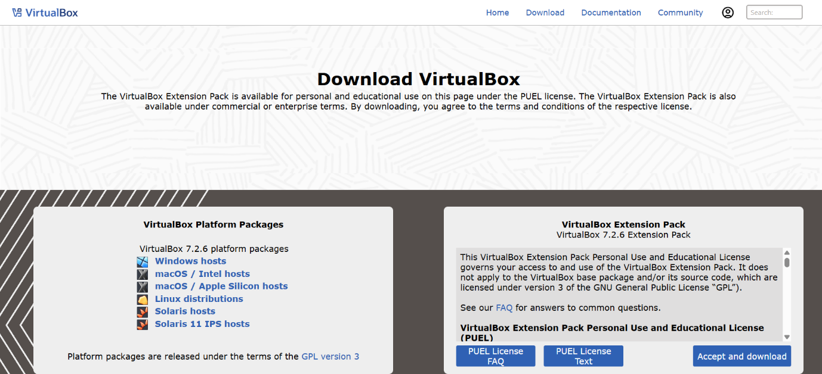
- Install on Windows and open it.
- Create a Virtual Machine by clicking on New.
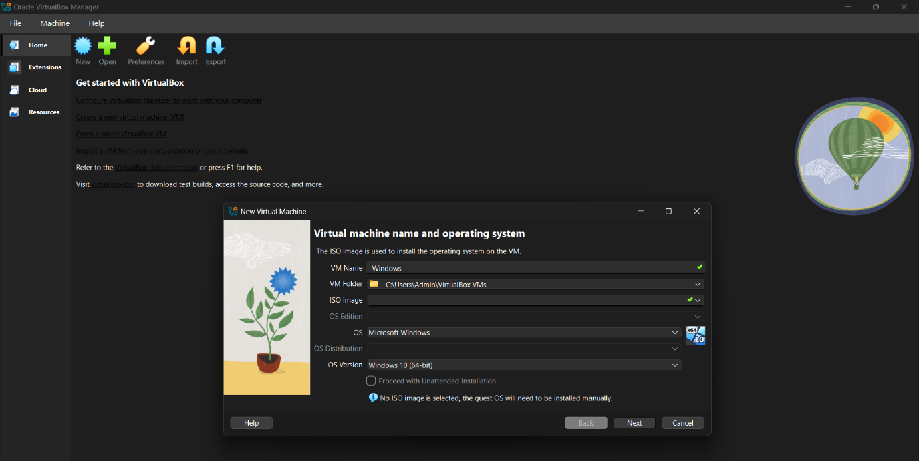
- Specify RAM size, HDD size, and network configuration, then finish the wizard.
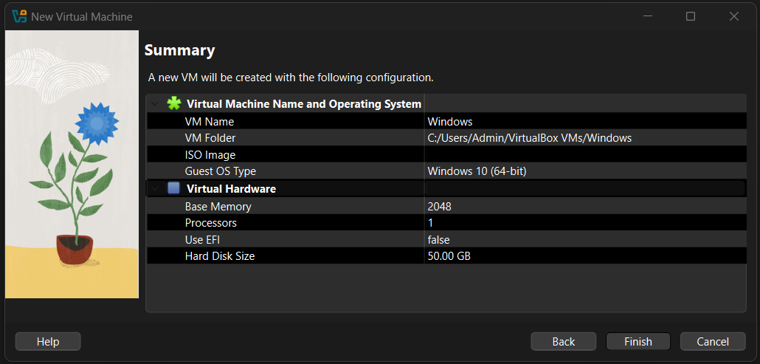
- Select the media for installation by clicking Start and browsing for the ISO file.
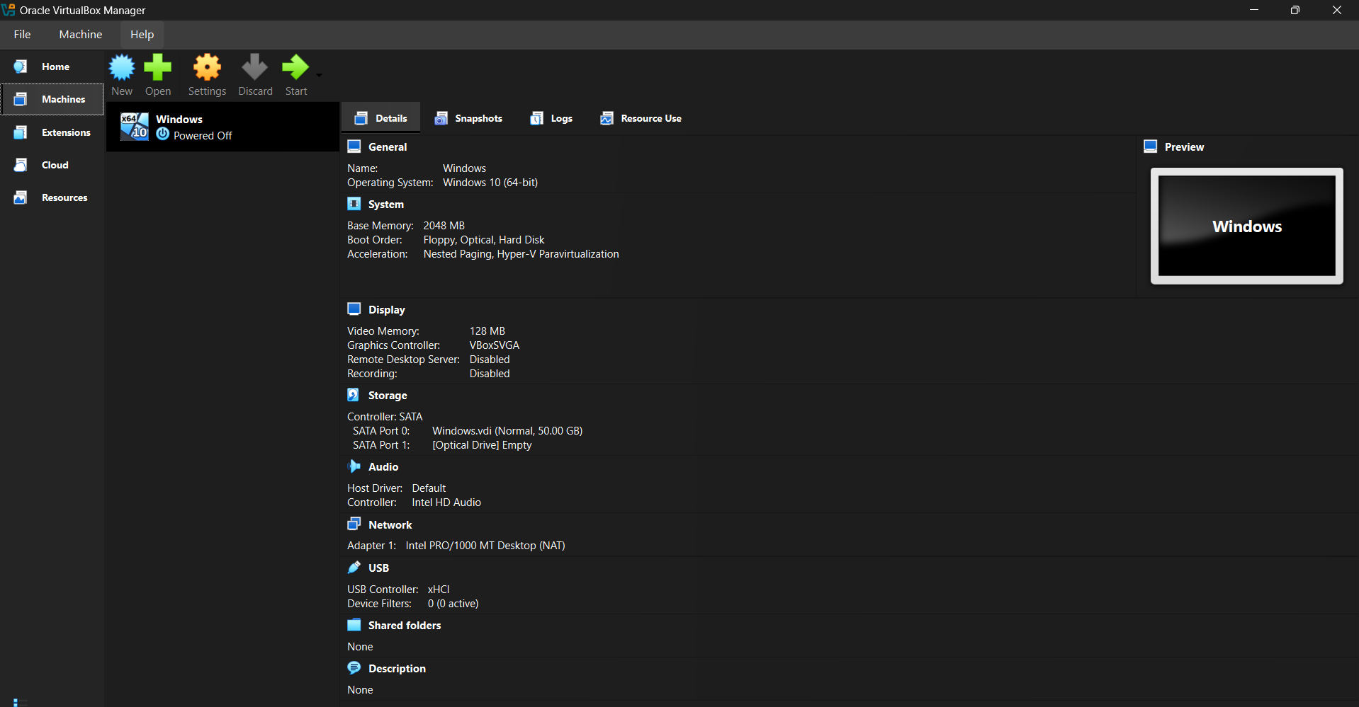

- Complete the installation and use it.
- Connect the OS to the network by changing the network mode to Bridge Adapter.
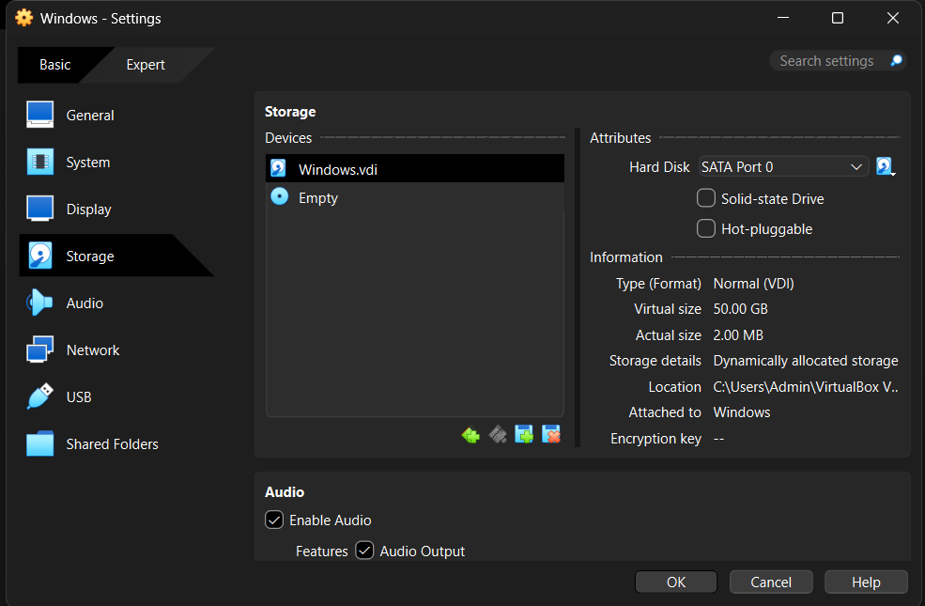
CONCLUSION:
In this experiment, we have successfully created and run virtual machines on a hosted hypervisor using VirtualBox.
REFERENCES:
- http://www.w3schools.com/
- http://www.nptelvideos.in/
- https://www.virtualbox.org/wiki/Downloads

